Resume
Henri Rosseau

Resume
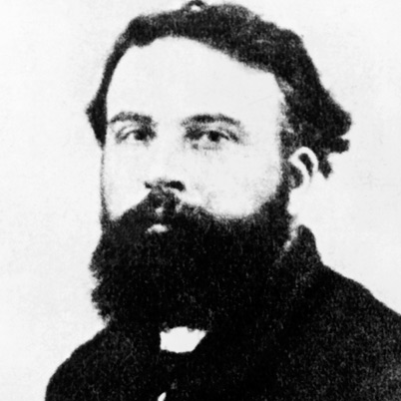
Henri Rosseau
Personal Information
Born: May 21, 1844, in Laval, Northern France
Status: Married to Josephine Noury
Address: 186 Boulevard Arago
My Paintings
I am a completely self-taught artist. My work is naïve and fantasy like. My imagination plays a major role in my paintings. Everything is drawn literally, the clouds look solid, and the costumes receive more attention than the figures themselves. It achieves a striking mood and mystery. I like to paint city and landscapes of Paris and its suburbs, but most of all I enjoy painting jungle scenes. I’ve never actually stepped foot into a jungle, but the ideas came from the displays at the museum I would visit often. I believe that I am a great artist and one of France’s best realist painters. I am well liked by other artists and they admire my work.
Work History
Served in the French Army from 1863-1868
1869-1893 Municipal Toll Collector- collected a fee from farmers coming to Paris markets.
Art Education
I never went to school for art, I am completely self taught. Although, I have received some painting advice from other great artists like Jean-Leon Gerome.

Hobbies & Interests
I love music and for some time I earned a little extra cash as a street musician. I am a talented violinist and also play the saxophone.

Portfolio Samples
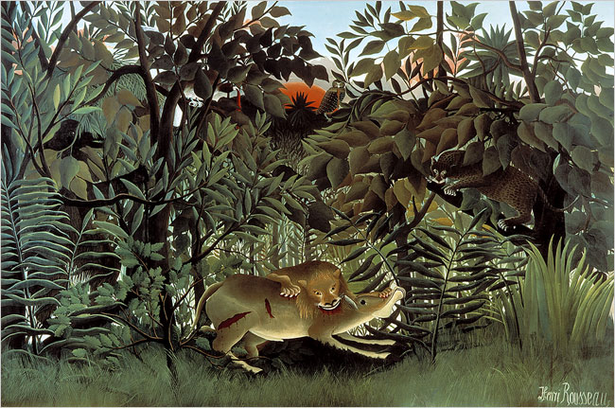
“The Hungry Lion Throws Itself on the Antelope”
“The lion, being hungry, throws itself on the antelope, [and] devours it. The panther anxiously awaits the moment when it too can claim its share. Birds of prey have each torn a piece of flesh from the top of the poor animal which sheds a tear. The sun sets.”
This is my second jungle scene that I have painted and finished it in 1905. It is a large oil on canvas painting. The Hungry Lion is in the jungle of thick green trees and grass lit by a deep red setting sun. In the foreground, the lion bites deeply into the neck of the antelope. Other animals are visible in the dense undergrowth. A panther watches from the right, and an owl stares out of the background. There are a couple birds in the painting and you have to look closely to be able to see them. The animals in the painting are based on the stuffed animals I saw at the Museum national d’histoire naturelle. I was a frequent visitor to the museum and the zoo. The displays in the natural history museum inspired the exotic imagery seen in my jungle paintings. The animals were often positioned in dramatic poses. This painting was shown at the Salon d’Automne in 1905 alongside the works of Matisse and Derain.

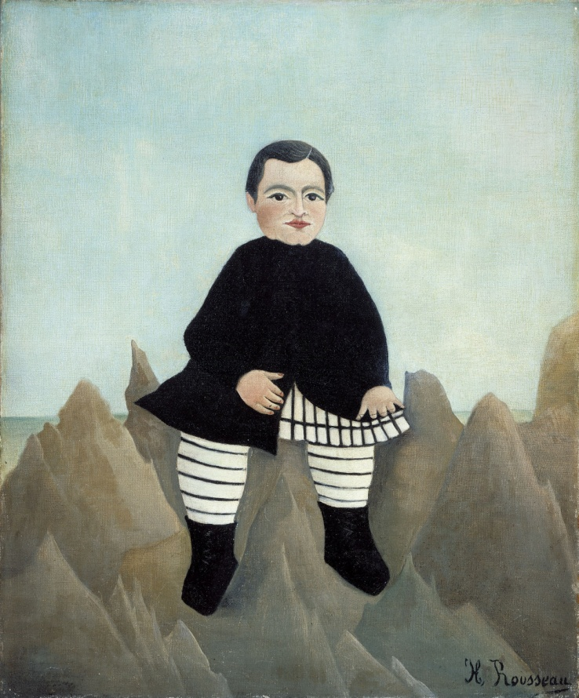
“Boy on the Rocks”
I painted this in 1895 and it is oil on linen. This painting of the boy on the rocks is both funny and alarming to people. The rocks seem to be like a series of mountain peaks and the child effortlessly dwarves them. His wonderfully stripy garments, his peculiar mask of a face, the uncertainty as to whether he is seated on the peaks or standing above them, all comes across with a sort of dreamlike force. With my simple, naïve vision, I can understand this elevation and make us see it as dauntingly true. I would say my paintings have a mysterious poetry behind them despite the disproportions and exaggerations. Throughout my career as an artist my painting style hasn’t changed but it has developed. It has developed into imaginative and unrealistic worlds. I consider myself one of the forerunners of the surrealist movement. My greatest wish was to paint in an academic style. I believe the pictures I have painted are real and convincing. The paintings have intense stylization, direct vision and fantastical images. I am a confident artist and can take any book and catalogue illustrations and turn each piece into fine art.

Works Cited
http://www.imdb.com/name/nm0745939/bio
http://www.encyclopedia.com/topic/Henri_Rousseau.aspx
http://www.artelino.com/articles/henri_rousseau.asp

